Projeto de Redes
Alunos:
Sabrina Mayume Silva Uezu 72.125.022-3
Kamila Dantas Luongo 72.225.010-7
Luciano Ventura Monegatto 72.126.015-6
Router 0:
Tipo de conexão | IP | Mascara
GigaEthernet 00 | 120.20.30.1 | 255.255.255.128
GigaEthernet 01 | 120.20.30.129 | 255.255.255.192
Serial 0/3/0 | 200.0.0.1 | 255.255.255.252

Router 1:
Tipo de conexão | IP | Mascara
GigaEthernet 00 | 192.168.0.1 | 255.255.192.0
GigaEthernet 01 | 192.168.64.1 | 255.255.192.0
Serial 0/3/0 | 200.0.0.2 | 255.255.255.252
Serial 0/3/1 | 200.0.0.5 | 255.255.255.252

Router 2:
Tipo de conexão | IP | Mascara
GigaEthernet 00 | 10.0.0.1 | 255.255.192.0
Serial 0/3/0 | 200.0.0.6 | 255.255.255.252

LAN 1:
Sub-Rede (01):120.20.30.0/25 - 255.255.255.128
Subredes | IP | Mascara | Gateway
PC1 | 120.20.30.10/25 | 255.255.255.128 | 120.20.30.1
PC0 | 120.20.30.11/25 | 255.255.255.128 | 120.20.30.1

Intervalo de IPs da Sub-Rede (01):
 | Mascara | Prefixo | 1ºEnd Val | Ult End | Broadcast
Sub-rede(01) | 255.255.255.128 | 120.20.30.0/25 | 120.20.30.1 | 120.20.30.126 | 120.20.30.127

Sub-Rede(02): 120.20.30.128/26 - 255.255.255.192
Sub-redes | IP | Mascara | Gateway
PC2 | 120.20.30.130/26 | 255.255.255.192 | 120.20.30.129
PC3 | 120.20.30.131/26 | 255.255.255.192 | 120.20.30.129
Server2 | 120.20.30.132/26 | 255.255.255.192 | 120.20.30.129
Server1 | 120.20.30.133/26 | 255.255.255.192 | 120.20.30.129

Intervalo de IP da Sub-Rede (02):
 | Mascara | Prefixo | 1ºEnd Val | Ult End | Broadcast
Sub-rede(02) | 255.255.255.192 | 120.20.30.128/26 | 120.20.30.129 | 120.20.30.190 | 120.20.30.191

LAN 2:
Sub-Rede única 192.168.0.0/18 - 255.255.192.0 e 192.168.64.0/18
Sub-redes | IP | Mascara | Gateway
PC4 | 192.168.0.10/18 | 255.255.192.0 | 192.168.0.1
PC5 | 192.168.0.11/18 | 255.255.192.0 | 192.168.0.1
PC6 | 192.168.64.10/18 | 255.255.192.0 | 192.168.64.1
PC7 | 192.168.64.11/18 | 255.255.192.0 | 192.168.64.1

Intervalo de IPs das Sub-Redes:
 | Mascara | Prefixo | 1ºEnd Val | Ult End | Broadcast
Sub-rede | 255.255.192.0 | 192.168.0.0/18 | 192.168.0.1 | 192.168.63.254 | 192.168.63.255
Sub-rede | 255.255.192.0 | 192.168.64.0/18 | 192.168.64.1 | 192.168.127.254 | 192.168.127.255

Lan 3 (Protocolo DHCP):
Sub-redes | IP | Mascara | Gateway
PC8 | 10.0.0.x/18 | 255.255.192.0 | 10.0.0.1
PC9 | 10.0.0.x/18 | 255.255.192.0 | 10.0.0.1
PC10 | 10.0.0.x/18 | 255.255.192.0 | 10.0.0.1
PC11 | 10.0.0.x/18 | 255.255.192.0 | 10.0.0.1
Server0 | 10.0.0.2/18 | 255.255.192.0 | 10.0.0.1
Laptop0 | 10.0.0.x/18 | 255.255.192.0 | 10.0.0.1
Laptop1 | 10.0.0.x/18 | 255.255.192.0 | 10.0.0.1
Laptop2 | 10.0.0.x/18 | 255.255.192.0 | 10.0.0.1

Intervalo de IP da Sub-Rede :
 | Mascara | Prefixo | 1ºEnd Val | Ult End | Broadcast
Sub-rede | 255.255.192.0 | 10.0.0.0/18 | 10.0.0.1 | 10.0.63.254 | 10.0.63.255

Servidor HTTP (página: index.html):
IP: 120.20.30.133
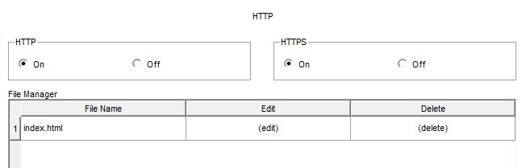
Server DNS:
IP: 120.20.30.132
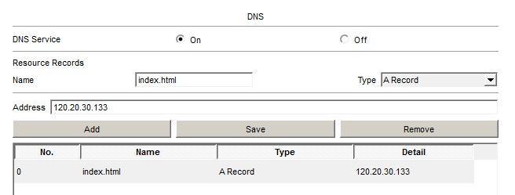
Acess-point com WPA2-PSK:
Senha de autenticação: 12345678
Acl para limitar o acesso da LAN3 para LAN2 no Router2: ip access-list extended 100
10 deny ip 10.0.0.0 0.0.63.255 192.168.0.0 0.0.255.255
20 permit ip any any interface GigabitEthernet0/0 ip access-group 100 in No Router1:
ip access-list extended 101
10 deny ip 192.168.0.0 0.0.255.255 10.0.0.0 0.0.63.255
20 permit ip any any
interface GigabitEthernet0/0 ip access-group 101 in interface GigabitEthernet0/1 ip access-group 101 in

